**BEEE (Electrical) Question Bank for IT 1**

Q1. Explain

1. Magnetic flux
2. Magnetic flux density
3. Magnetic intensity
4. Magnetic potential
5. Permeability
6. Reluctance
7. Mmf
8. Right hand thumb rule
9. Left hand rule
10. Ampere law
11. Biot savarts law
12. Magnetic circuits
13. Leakage flux
14. Magnetic leakage
15. Fringing
16. Faradays laws (First and second)
17. Lenz law
18. Right hand law
19. B and H curve
20. Ohms law
21. Kirchoffs law

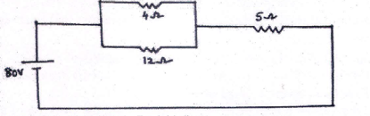Q2. Give a comparison of magnetic and electric circuits.

Q3. Explain source conversion with an example.

Q4. For the given network, determine

Figure 1

1. Voltage across each resistor
2. 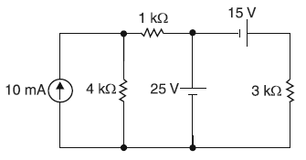Current through each resistor

Q5. Solve using (Figure 2)

1. Mesh Analysis
2. Nodal Analysis

Q6. Assignment questions on Power Plants.

Figure 2